**System Testing**

* In system testing the behavior of whole system/product is tested as defined by the scope of the development project or product. It may include [**tests based on risks**](http://istqbexamcertification.com/what-is-risk-based-testing/) and/or [**requirement specifications**](http://istqbexamcertification.com/what-is-functional-testing-testing-of-functions-in-software/), business process, use cases, or other high level descriptions of system behavior, interactions with the operating systems, and system resources.
* System testing is most often the final test to verify that the system to be delivered meets the specification and its purpose.
* System testing is carried out by specialist’s testers or [**independent testers**](http://istqbexamcertification.com/what-is-independent-testing-its-benefits-and-risks/).
* System testing should investigate both [**functional**](http://istqbexamcertification.com/what-is-functionality-testing-in-software/) and [**non-functional requirements**](http://istqbexamcertification.com/what-is-non-functional-testing-testing-of-software-product-characteristics/) of the testing.
* System Testing (ST) is a black box testing technique performed to evaluate the complete system the system's compliance against specified requirements. In System testing, the functionalities of the system are tested from an end-to-end perspective.
* System Testing is usually carried out by a team that is independent of the development team in order to measure the quality of the system unbiased. It includes both functional and Non-Functional testing.
* **System testing:**The process of testing an integrated system to verify that it meets specified  
  requirements.

**ANALOGY**

During the process of manufacturing a ballpoint pen, the cap, the body, the tail, the ink cartridge and the ballpoint are produced separately and unit tested separately. When two or more units are ready, they are assembled and Integration Testing is performed. When the complete pen is integrated, System Testing is performed.

**METHOD**

Usually, [Black Box Testing](http://softwaretestingfundamentals.com/black-box-testing/) method is used.

**TASKS**

* System Test Plan
  + Prepare
  + Review
  + Rework
  + Baseline
* System Test Cases
  + Prepare
  + Review
  + Rework
  + Baseline
* System Test
  + Perform

System testing is the testing of a complete and fully integrated software product.

Usually software is only one element of a larger computer based system. Ultimately, software is interfaced with other software/hardware systems.

System testing is actually a series of different tests whose sole purpose is to exercise the full computer based system.   
  
**Two Category of Software Testing**

* Black Box Testing
* White Box Testing

System test falls under the **black box testing** category of software testing.

**White box testing** is the testing of the internal workings or code of a software application. In contrast, black box or system testing is the opposite. System test involves the external workings of the software from the user's perspective.

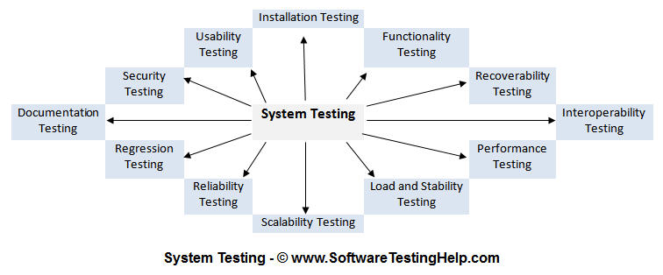

Types of System Tests:

